Evaluating the performance, feasibility, acceptability and impact of treatment-decision algorithms for the detection of pulmonary TB in children
TDA4Child study

Protocol Annexes
Version: 1
April 2023

Table of Contents
Annex 1 Consensus definition of intra-thoracic tuberculosis in children 3
Annex 2 Diagnostic Algorithms 4
Annex 3 Informed Consent Form 6
Annex 4 Terms of Reference for the Endpoint Review Committee 11
Annex 5 Health Care Worker Informed Consent Form 13
Annex 6 Semi-structured healthcare worker questionnaire 15
Annex 7 Informed Assent Form 22
Annex 8 Assent Information Script 23
Annex 9 Sample Size Permutations 25

Annex 1 Consensus definition of intra-thoracic tuberculosis in children
Adapted from Table 2 - Graham SM, Cuevas LE, Jean-Philippe P, Browning R, Casenghi M, Detjen AK, et al. Clinical Case Definitions for Classification of Intrathoracic Tuberculosis in Children: An Update. Clin Infect Dis. 2015;61Suppl 3:S179-87.
Case definition | Criteria
Confirmed tuberculosis | Bacteriological confirmation obtained  Requires Mycobacterium tuberculosis to be confirmed (positive smear microscopy or culture, mWRD, or LF-LAM) from at least 1 appropriate specimen
Unconfirmed tuberculosis | Bacteriological confirmation NOT obtained AND at least 2 of the following:  - Symptoms/signs suggestive of tuberculosis (as defined)  - Chest radiograph consistent with tuberculosis  - Close tuberculosis exposure or immunologic evidence of M. tuberculosis infection  - Positive response to tuberculosis treatment (requires documented positive clinical response on tuberculosis treatment-no time duration specified)
Unlikely tuberculosis | Bacteriological confirmation NOT obtained AND  Criteria for "unconfirmed tuberculosis" NOT met  OR other clinical diagnosis made with clinical improvement without TB treatment
Unclassifiable | Another case definition cannot be assigned due to operational factors – for example a child is lost to follow-up
Abbreviations: IGRA – interferon-γ release assay; LF-LAM - lateral flow lipoarabinomannan assay; mWRD - molecular WHO-recommended rapid diagnostic test; TST - tuberculin skin test

Annex 2 Diagnostic Algorithms
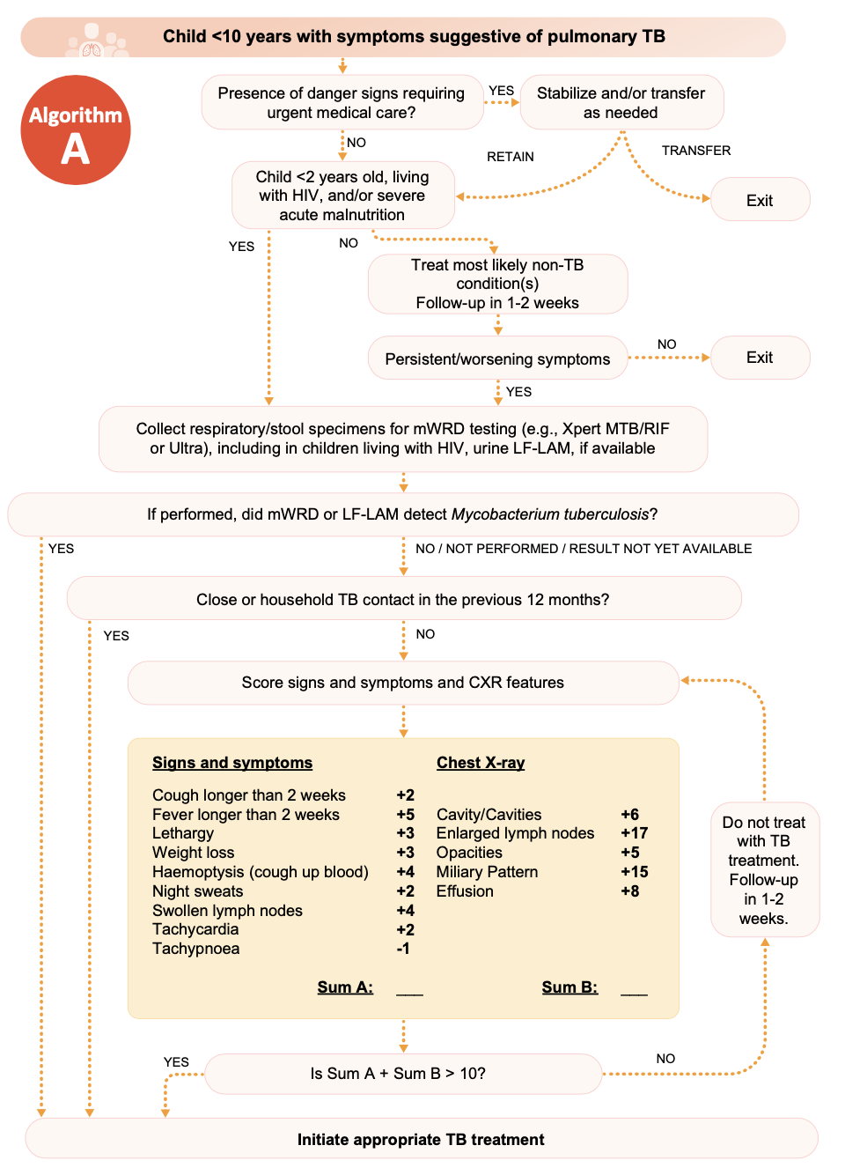
Algorithm A for study sites with access to x-ray

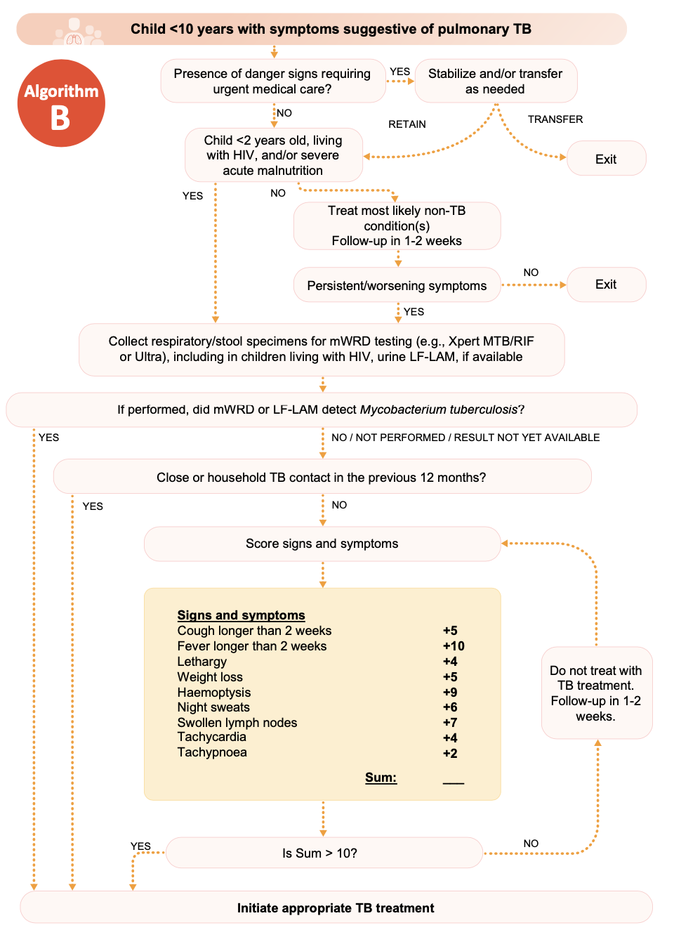
Algorithm B for sites without access to x-ray

Annex 3 Informed Consent Form

Evaluating the performance of treatment-decision algorithms for the detection of pulmonary TB in children
[[ Implementing organisation name ]]
Participant informed consent
[[ Implementing organisation name ]] invite you and your child to participate in a study to find out how accurate a combination of tests are at diagnosing tuberculosis in the lungs. Please read the following information so that you can make an informed decision about whether to participate in the study. If you would prefer, this document can be read to you.
Tuberculosis (TB)
Your child is attending this clinic because they have symptoms that might be caused by tuberculosis - an infection transmitted through the air. While tuberculosis in children can be treated with medicines, confirming the diagnosis with tests can be difficult because collecting sputum from children can be hard and because laboratory tests aren’t as accurate for tuberculosis in children.
Purpose of study
This study will describe a new approach to combining tests to help health workers decide when it’s appropriate to start treatment for tuberculosis in children. The new approach evaluates the symptoms your child may be suffering with and organises the appropriate tests to establish whether tuberculosis is the reason your child is sick. While the evaluation of symptoms and the use of diagnostic tests for tuberculosis have always been important in detecting childhood TB, the use of this specific approach is only recently recommended by the World Health Organization. By assessing whether this combination approach improves the diagnosis of TB in children, this study will help experts to improve future national and international recommendations.
Study participation
If you choose for your child to participate in the study, they will be assessed for TB based on this combination approach. The individual steps in the process have been used in child TB clinics for many years – this study seeks to describe the combination and order of the different steps. Further information about the combination is included in the patient information leaflet.
If your child is too sick to participate in this study, the doctor/nurse will refer you to another health clinic for urgent evaluation and management. This process will be managed by the clinic staff in discussion with you.
An important step to diagnosing TB in children can be to treat other common conditions that may cause similar symptoms. The assessment may recommend initially treating other common infections before returning 2 weeks later, or earlier if symptoms worsen, for re-evaluation. It is important that any medicines prescribed by the doctor/nurse are taken according to the instructions given to you.
When symptoms continue despite treatment for other common conditions, further testing for TB is required. It is likely that stool, urine, and/or sputum will be required from your child for TB testing. Getting sputum from children, especially younger children, can be hard. Clinic staff will discuss with you how they routinely get sputum from younger children even when they’re not able to cough it up. If your clinic has access to an x-ray machine, the staff may also arrange for a chest x-ray to help diagnose TB.
The results of these tests, along with information that you provide about your child’s symptoms and possible contact with TB, will be considered by the doctor/nurse who will then judge whether treatment for TB should be started. They may decide that the best approach is to not start treatment, but to re-evaluate the information and any new changes after 2 weeks. Whether treatment is started or not, they will explain their decision and what is expected from you.
The final step in deciding how accurate this new combination of tests is, is to check on your child after 2 months. To do this, they will either invite you back to the clinic for your child to be seen by the doctor/nurse or will speak to you on the telephone.
Risks
We do not expect any new risks to you or your child from participation in this study since the all the decisions about your child’s treatment will continue to be made by your doctor or nurse. Participation in the study does require a follow-up appointment 2 months after the assessment which some may feel is inconvenient. If attending the clinic after 2 months is too inconvenient for you, speak to the clinic staff about the possibility of using a telephone consultation instead.
Benefits
Participation in the study will ensure that a standardised assessment for TB is conducted on your child. This may or may not include assessments or tests which are routinely performed at your clinic when a child is evaluated for TB. The result of the combination assessment will be available to your doctor or nurse when they decide how to best manage your child.
We believe the study will help to improve the future diagnosis of TB in children by improving our knowledge of the use of combinations of tests.
There will be no financial benefits to you associated with participation in this study although some costs may be reimbursed. Speak to the clinic staff for more information.
Participant rights and confidentiality
You have the right to refuse to participate at any moment during the study even after initially agreeing for your child to participate. Your decision at any time will be respected and this will not affect the quality of care you will receive.
Your participation in the study will be confidential although healthcare staff will always have access to important clinical information to provide the best possible care for your child. All information, including test results, relating to you or your child will be stored in a secure and safe manner. Any specimens (e.g., stool, urine, blood, sputum) taken from your child will be used only for diagnostic testing and will then be destroyed. Your names or will not be shared or included in any report. When analysing the study data, anonymous identification numbers will be used. Information and materials relating to the study must be retained for several years after its completion. After that period, they will be destroyed in according to the rules in your country.
Caregiver responsibilities
By agreeing for your child to participate in this study, you confirm that you are the parent or legal guardian of the child and agree to providing information relating to your child’s health requested by the nurse. You also agree to a follow-up appointment 2 months after the initial assessment.
Study team’s contact information
You may have questions about this diagnostic study. You are free to ask our nurse any questions you may have now. If you have questions later, you can call or write to [[ study team member contact details ]]

Evaluating the performance of a treatment decision algorithm for the detection of childhood TB
[[ Implementing organisation name ]]
Participant informed consent
Patient identification number: __________
I ____________________________________ (insert name of household head, father, mother, caretaker of child/ren here) have been informed and have fully understood the purpose of this study and the samples that are being requested from the child in my care.
I understand the information and give permission for my child to participate in this study evaluating a diagnostic algorithm for childhood tuberculosis:

Child 1 (insert name) ____________________________________________________

I understand that I have the right to refuse without having to give a reason. I give voluntary consent for participation in this study and understand that I am free to withdraw the child from the study at any time and face no penalty.
I have understood the information sheet and my questions have been answered to my satisfaction.

Date: ¦_D_¦ ¦_D_¦ / ¦_M_¦ ¦_M_¦ /¦_Y_¦ ¦_Y_¦
Caregiver’s signature/fingerprint | Impartial witness signature (as applicable)

Caregiver’s name | Impartial witness name (as applicable)

Study team member name and signature:
___________________________________________________________________

Annex 4 Terms of Reference for the Endpoint Review Committee

Introduction
Investigators should include a short description of the study – some example text is included below.
In 2022, the World Health Organization updated their recommendations for the initiation of treatment for children under 10 years old with presumptive pulmonary tuberculosis. A new conditional, interim recommendation advocated for the use of treatment-decision algorithms for such children attending health care facilities. Uncertainty about the benefit of this approach resulted in the Guideline Development Group restricting the validity of the recommendation to 24 months with the intention to review newly generated data.
This study will contribute experience of using treatment decision algorithms in [[ name of country ]] through the collection of accuracy, feasibility and acceptability data.
The endpoint review committee will provide expert evaluations of end of follow-up gold-standard assessments to maximise confidence in situations where there may be uncertainty.

Membership, meetings, administration
Include a description of who will serve on the committee and how they will be chosen. Since the study duration is short, no changes in membership should be expected. Adjust the text below as required.
- The committee will be chosen by the study investigators and will serve for the duration of the study.
- The committee will consist of 5 members and will meet virtually or in-person once every 3 months.
- The Chairperson will be designated by the study investigators.
- Each member must have sufficient expertise in the evaluation of children with respiratory illnesses and the diagnosis of tuberculosis. [[ Define this expertise for the study context – e.g. paediatrician, other formal training, practical experience ]]
- The study team will coordinate meetings and the sharing of relevant information between committee members.

Responsibilities
Committee members will review case descriptions referred by study investigators in the following situations:
- A child dies during the algorithm assessment or the 2-month follow-up period
- A treating clinician disregards the algorithm-derived treatment decision when evaluating a child
The primary aim of the committee is to review the reference standard evaluation for each referred case.
Each referred case will be reviewed during the quarterly committee meetings. Where a consensus cannot be reached between the three members, the case will be adjudicated by the Chairperson. Recommendations from the committee should be provided to the study team within 14 days of each quarterly meeting. Any recommended changes to a study endpoint should be recorded in the study data set by the study team.
The study team will coordinate the referral process and will ensure referring information is sufficiently complete.

Annex 5 Health Care Worker Informed Consent Form

Evaluating the performance of a treatment decision algorithm for the detection of childhood TB
[[ Implementing organisation name ]]
Healthcare worker feasibility evaluation
Healthcare worker number: ________________

I ____________________________________ (insert name of healthcare worker here) have been informed and have fully understood the purpose of this study and the information being requested from me.
I understand the information about the study and agree to participate in this study evaluating a diagnostic algorithm for childhood tuberculosis:

Healthcare worker (insert name) ____________________________________________________

I understand that I have the right to refuse without having to give a reason. I give voluntary consent for participation in this study and understand that I am free to withdraw from the study at any time and face no penalty.
I have understood the information sheet and my questions have been answered to my satisfaction.
Date: ¦_D_¦ ¦_D_¦ / ¦_M_¦ ¦_M_¦ /¦_Y_¦ ¦_Y_¦
Healthcare workers signature/fingerprint | Impartial witness signature (as applicable)

Impartial witness name (as applicable)
Study team member name and signature:

___________________________________

Annex 6 Semi-structured healthcare worker questionnaire

Evaluating the performance of a treatment decision algorithm for the detection of childhood TB

Implementation survey for Health Care Workers applying the treatment decision algorithm

Background information
Participant ID: _________________________
Questionnaire completion date: _________________________
District: [[ add list of study districts ]]
Study site: [[add list of study sites ]]
What is your gender?
Female
Male
Other (please specify): _________________________
How old are you?
18-24
25-34
35-44
45-54
55-64
65 or older

What is your role in the health care facility?
Doctor
Clinical Officer
Nurse
Community health worker
Other (please specify): _________________________

How many years have you worked in this role? _________

What is the highest level of education you completed?
Primary school
Secondary school
Post-secondary certificate
Bachelor’s degree through a university or higher
Other (please specify): _________________________

Have you received any specific training for
Tuberculosis
Childhood tuberculosis
Diagnosis of childhood illnesses
If so, please describe the training you have received and when you last participated:
__________________________________________________
__________________________________________________
__________________________________________________

Approximately how many children (under 10 years) with presumptive TB do you see each week? _________

Access to experienced practitioners
What level is the most senior clinician at your health facility every day?
Doctor
Clinical Officer
Nurse
Community health worker
Other (please specify): _________________________

How would you get advice from a more experienced clinician or colleague?
On-site request
Telephone
Refer the child – caregiver arranges transportation
Refer the child – health system provides transportation
Other (please specify): _________________________

Experience applying the treatment decision algorithm

Feasibility
I received adequate training to use the treatment decision algorithm
Strongly disagree
Somewhat disagree
Somewhat agree
Strongly agree

The instructions for the treatment decision algorithm are easy to follow
Strongly disagree
Somewhat disagree
Somewhat agree
Strongly agree

Assigning a score through the treatment decision algorithm is easy to do
Strongly disagree
Somewhat disagree
Somewhat agree
Strongly agree

The health facility has sufficient resources to always allow implementation of the treatment decision algorithm
Strongly disagree
Somewhat disagree
Somewhat agree
Strongly agree

Acceptability
I feel comfortable using the treatment decision algorithm
Strongly disagree
Somewhat disagree
Somewhat agree
Strongly agree

The treatment decision algorithm provides guidance in a timely way
Strongly disagree
Somewhat disagree
Somewhat agree
Strongly agree

I feel confident in applying the decision recommended by the algorithm
Strongly disagree
Somewhat disagree
Somewhat agree
Strongly agree

Appropriateness
The treatment decision algorithm appears to detect TB in children well
Strongly disagree
Somewhat disagree
Somewhat agree
Strongly agree

The treatment decision algorithm helps me to provide better care for children and their caregivers
Strongly disagree
Somewhat disagree
Somewhat agree
Strongly agree

I would recommend using the treatment decision algorithm to my colleagues or other health facilities
Strongly disagree
Somewhat disagree
Somewhat agree
Strongly agree

Open questions
For the following questions please provide as much description as possible about your experiences and opinions using the treatment decision algorithm.
What is your opinion about the instructions which support the treatment decision algorithm? Please describe what you liked about them or what you didn't like about them.

………………………………………………………………………………………………………………………………………

………………………………………………………………………………………………………………………………………

………………………………………………………………………………………………………………………………………

………………………………………………………………………………………………………………………………………

What would you change about the instructions?

………………………………………………………………………………………………………………………………………

………………………………………………………………………………………………………………………………………

………………………………………………………………………………………………………………………………………

………………………………………………………………………………………………………………………………………

Have you found the treatment decision algorithm helpful? If so, in what ways?

………………………………………………………………………………………………………………………………………

………………………………………………………………………………………………………………………………………

………………………………………………………………………………………………………………………………………

………………………………………………………………………………………………………………………………………

What problems have you experienced due to the treatment decision algorithm? Describe any problems with the algorithm itself or any other consequences of using the algorithm.

………………………………………………………………………………………………………………………………………

………………………………………………………………………………………………………………………………………

………………………………………………………………………………………………………………………………………

………………………………………………………………………………………………………………………………………

If you could, what would you change about the treatment decision algorithm or its implementation in your clinic?

………………………………………………………………………………………………………………………………………

………………………………………………………………………………………………………………………………………

………………………………………………………………………………………………………………………………………

………………………………………………………………………………………………………………………………………

If you have any questions regarding the questionnaire or how to fill it in, please contact the study investigator [[ include study investigator’s name and contact telephone number ]]

Annex 7 Informed Assent Form

Evaluating the performance of treatment-decision algorithms for the detection of pulmonary TB in children
[[ Implementing organisation name ]]

Child assent consent
Patient identification number: __________
The study staff have read the information to me and have had my questions answered. I also know that I can ask more questions later.
Tick appropriate:
¦_ _¦ I agree to take part in the research OR
¦_ _¦ I do not wish to take part in the research and I have not signed the assent form below

Date: ¦_D_¦ ¦_D_¦ / ¦_M_¦ ¦_M_¦ /¦_Y_¦ ¦_Y_¦
Child’s signature/fingerprint

Child’s name

Study team member name and signature:
___________________________________________________________________

Copy provided to the child _______ (initialled by the researcher)

Annex 8 Assent Information Script
This script is included for illustrative purposes. Information for 6–10-year-olds eligible for participation in the study should be spoken in their favoured language and tailored to the study context.
We would like you and your mum or dad or the grown up looking after you to help us with our research study. We will explain why the study is being done and what it will involve. If something isn’t clear or if you have more questions, you can ask your mum or dad or grown up that looks after you.

Why am I being asked about this?
Your mum, dad or grown up that looks after you has noticed that you have been having some trouble with your breathing or have been coughing. They brought you to the clinic to be checked by the staff. Because of this breathing trouble or cough they think we will need to look for an important infection that often affects the lungs called tuberculosis.
Tuberculosis is quite common in [[ describe country/district ]] so it wouldn’t be unusual if you’re sick because of it. Treatment is good but does mean taking tablets every day for some time. If after checking you carefully for tuberculosis, the staff don’t think that’s the problem, they will need to think about other reasons you’re sick.

Why are we doing this research study?
A research study is something you do when you want to learn about something and answer questions. Right now, we’re trying to understand the best way to find tuberculosis when a child gets sick. We’re using a new list of tests for children who are sick then seeing how well this works when compared to what we used to use. If the new approach is better, we’ll suggest using it in other places too so that other children can benefit.
Although the list of tests is new, the tests themselves have been used for a long time. We know that they’re safe.

Do you have to help? What will happen?
You can help if you want. If you don’t want to, that’s okay too, nobody will mind. You can tell us why you didn’t want to help if you like. If you do agree to help, the clinic staff will ask you some questions, examine you and do some tests. They will involve blood tests. This part is similar to how it would be even if there was no research study.
After getting all your results, the staff will decide whether they think tuberculosis is making you sick. If they think tuberculosis is the cause, then they’ll give you treatment. If they don’t think tuberculosis is the cause, they may give you another treatment, or do more tests, or even wait to see what happens without any new treatment.
For the research study, we’d like you to come back to the clinic two months after this visit with your mum, dad or grown up that looks after you. We will want to know whether you’re feeling better.

Will anything good or bad happen to me if I take part?
Nothing bad will happen to you for choosing to help us. If you are worried, tell your family or the staff in the clinic. We hope the study will help other children by trying to find out the best way to find tuberculosis. If you enjoyed helping with this study, you can tell us later on.

What do I have to do now?
If you want to help, your mum, dad or grown up looking after you need to say it’s okay. If you have more questions, you can ask your mum, dad or the grown up looking after you. You can also ask the clinic staff.

Annex 9 Sample Size Permutations
Sample size estimates based on assumed 5% loss to follow up, and presented algorithm sensitivity, TB prevalence amongst include participants, accuracy of sensitivity estimate and statistical power.
Sensitivity | Prevalence | Precision | alpha | Subjects
0.7 | 0.02 | 0.1 | 0.05 | 4,246
0.8 | 0.02 | 0.1 | 0.05 | 3,235
0.9 | 0.02 | 0.1 | 0.05 | 1,820
0.7 | 0.03 | 0.1 | 0.05 | 2,831
0.8 | 0.03 | 0.1 | 0.05 | 2,157
0.9 | 0.03 | 0.1 | 0.05 | 1,214
0.7 | 0.04 | 0.1 | 0.05 | 2,123
0.8 | 0.04 | 0.1 | 0.05 | 1,618
0.9 | 0.04 | 0.1 | 0.05 | 910
0.7 | 0.05 | 0.1 | 0.05 | 1,699
0.8 | 0.05 | 0.1 | 0.05 | 1,294
0.9 | 0.05 | 0.1 | 0.05 | 728
0.7 | 0.06 | 0.1 | 0.05 | 1,416
0.8 | 0.06 | 0.1 | 0.05 | 1,079
0.9 | 0.06 | 0.1 | 0.05 | 607
0.7 | 0.07 | 0.1 | 0.05 | 1,214
0.8 | 0.07 | 0.1 | 0.05 | 925
0.9 | 0.07 | 0.1 | 0.05 | 520
0.7 | 0.08 | 0.1 | 0.05 | 1,062
0.8 | 0.08 | 0.1 | 0.05 | 809
0.9 | 0.08 | 0.1 | 0.05 | 455
0.7 | 0.09 | 0.1 | 0.05 | 944
0.8 | 0.09 | 0.1 | 0.05 | 719
0.9 | 0.09 | 0.1 | 0.05 | 405
0.7 | 0.10 | 0.1 | 0.05 | 850
0.8 | 0.10 | 0.1 | 0.05 | 647
0.9 | 0.10 | 0.1 | 0.05 | 364
0.7 | 0.11 | 0.1 | 0.05 | 772
0.8 | 0.11 | 0.1 | 0.05 | 589
0.9 | 0.11 | 0.1 | 0.05 | 331
0.7 | 0.12 | 0.1 | 0.05 | 708
0.8 | 0.12 | 0.1 | 0.05 | 540
0.9 | 0.12 | 0.1 | 0.05 | 304
0.7 | 0.13 | 0.1 | 0.05 | 654
0.8 | 0.13 | 0.1 | 0.05 | 498
0.9 | 0.13 | 0.1 | 0.05 | 280
0.7 | 0.14 | 0.1 | 0.05 | 607
0.8 | 0.14 | 0.1 | 0.05 | 463
0.9 | 0.14 | 0.1 | 0.05 | 260
0.7 | 0.15 | 0.1 | 0.05 | 567
0.8 | 0.15 | 0.1 | 0.05 | 432
0.9 | 0.15 | 0.1 | 0.05 | 243
0.7 | 0.16 | 0.1 | 0.05 | 531
0.8 | 0.16 | 0.1 | 0.05 | 405
0.9 | 0.16 | 0.1 | 0.05 | 228
0.7 | 0.17 | 0.1 | 0.05 | 500
0.8 | 0.17 | 0.1 | 0.05 | 381
0.9 | 0.17 | 0.1 | 0.05 | 215
0.7 | 0.18 | 0.1 | 0.05 | 472
0.8 | 0.18 | 0.1 | 0.05 | 360
0.9 | 0.18 | 0.1 | 0.05 | 203
0.7 | 0.19 | 0.1 | 0.05 | 447
0.8 | 0.19 | 0.1 | 0.05 | 341
0.9 | 0.19 | 0.1 | 0.05 | 192
0.7 | 0.20 | 0.1 | 0.05 | 425
0.8 | 0.20 | 0.1 | 0.05 | 324
0.9 | 0.20 | 0.1 | 0.05 | 182

